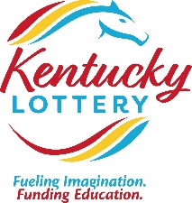

1011 West Main Street
Louisville, KY 40202
PHONE: 502-560-1551
tom.delacenserie@kylottery.com

THOMAS R. DELACENSERIE
President & CEO

TO: Governor Matt Bevin
President of the Senate Robert Stivers
House Speaker Pro Tempore David Osborne

FROM: Tom Delacenserie

DATE: March 22, 2019

SUBJECT: FEBRUARY MONTHLY REPORT

For the second month in a row, scratch-off sales were the highlight reaching 5.6% more than budget, in addition to sales increasing 13.7% from last year. Year-to-date sales continue to be ahead of budget with Mega Millions and scratch-offs sales accounting for the majority of those increases.

In celebration of the KLC’s 30th year, we launched our first ever $30 ticket—Break Fort Knox, with a $3 million top prize claimed the first week. The game is packed with winners from $50-$10,000 and offers a total of four $3 million top prizes. This is the largest top prize ever offered on any Kentucky Lottery scratch-off game. In addition, we also launched a new nightly draw game, Kentucky’s Quick Bucks. The unique feature about this game is the “wheel bet” that essentially guarantees a $2 win, and possibly much more, when you make the $5 wheel bet.

The KLC continued to address the 2018 Wire Act Opinion of the U.S. Department of Justice. Along with our lottery system vendors and the lottery industry as a whole, we are exploring the possible remedies and options which may be available for relief.

The KLC Board of Directors met on March 22, 2018, and approved the following: an agreement with Smartplay for draw machine maintenance; a contract renewal with Gaming Laboratories for lottery ball testing and random number generator evaluation, contracts with Goldberg Simpson & Valenti Hanley for legal services; contract with Ellen Williams LLC & Akin Gump Hauer & Felp for government relations services; an increase to the approved FY19 capital budget by $268,000 for new facilities construction, and various game rules/regulations.

The entire package of the February financial statements is attached. Below is a brief synopsis of
February 2019 compared to prior year and budget.

February 2019 vs. Prior Year and Budget
SALES
 | Amount ('000s) |  | % change vs. Prior Year |  | % change vs. Budget
Total Sales | 88,661 |  | 8.6% |  | 0.7%
Instant Sales | 54,903 |  | 13.7% |  | 5.6%
Draw Sales | 32,317 |  | -0.2% |  | -6.8%
iLottery Instant Play Sales | 1,441 |  | 45.9% |  | 2.9%
EXPENSES
 | Amount ('000s) |  | % change vs. Prior Year |  | % change vs. Budget
Prize Expense | 58,283 |  | 13.1% |  | 2.1%
Overall Prize Payout % | 65.7% |  | 2.2% |  | 0.7%
Operating Expenses | 2,343 |  | -15.0% |  | -11.0%
INCOME/TRANSFERS
 | Amount ('000s) |  | % change vs. Prior Year |  | % change vs. Budget
Income Before Transfer of Dividends | 20,951 |  | 2.3% |  | -0.1%
KLC Transfers (General Fund) | 20,000 |  | 0.0% |  | 0.0%
KEES Reserve Fund (Accrued) | 240 |  | -84.1% |  | -68.0%

Respectfully submitted,
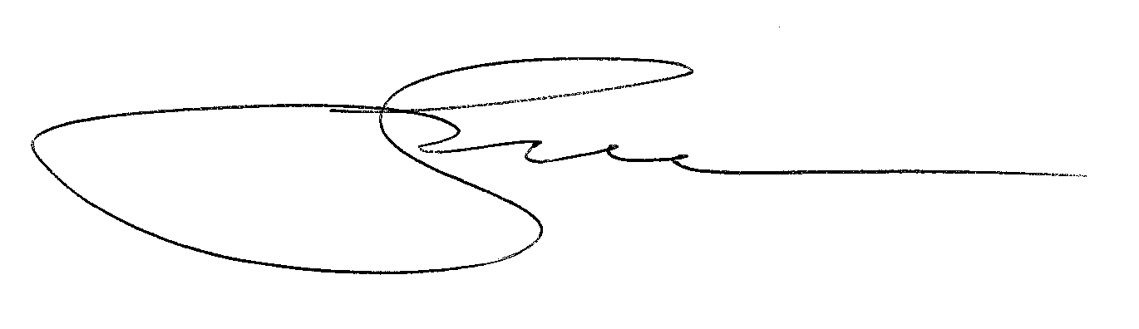
cc: KLC Chairman Sommer
/tmp/in/input.doc

